Python Project Setup, Git, and GitHub Workflow - Worksheet
Student Name:Nancy Jelagat Tenai
Date: 17/09/2026
GitHub Repository: https://github.com/Nancy1989-Tenai

Part A - Project Setup Using the CLI
Screenshot 1: Directory Tree
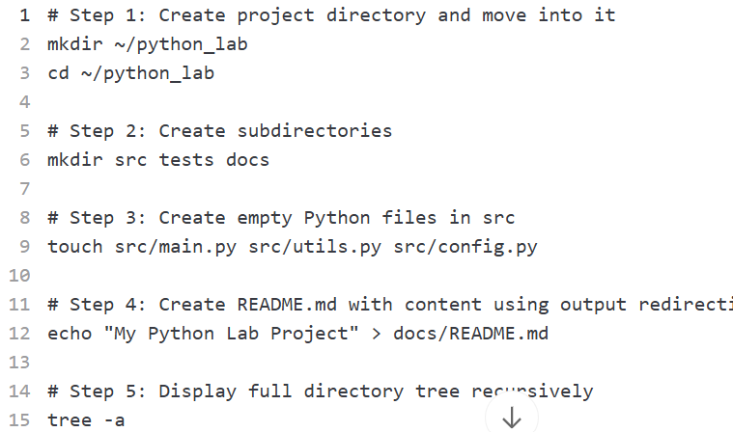

Command Explanations:
The commands used in Part A accomplish the following tasks: mkdir ~/python_lab creates a new directory called python_lab in the home directory, establishing the project root. cd ~/python_lab changes the current working directory to this newly created folder. mkdir src tests docs creates three subdirectories that organize the project structure - src for source code, tests for test files, and docs for documentation. touch src/main.py src/utils.py src/config.py creates three empty Python files in the src directory, which will contain the application code. echo "My Python Lab Project" > docs/README.md writes the specified text to README.md using output redirection, creating a simple documentation file without opening a text editor. Finally, tree -a displays the complete directory structure recursively, including hidden files, providing a visual overview of the project organization.
Why Separate into src, tests, and docs:
Separating code into src, tests, and docs directories follows best practices for project organization, even in small projects. The src directory keeps all source code in one place, making it easy to locate and maintain. The tests directory isolates test files, enabling automated testing without cluttering the main codebase. The docs directory stores documentation separately, ensuring users and developers can find project information quickly. This structure scales well as the project grows and makes collaboration easier by establishing clear conventions for where different types of files belong. It also simplifies deployment processes, as only the src directory might need to be packaged for production, while tests and docs remain separate for development and reference purposes.

Part B - Git Initialization and First Commit
Screenshot 2: Commit History
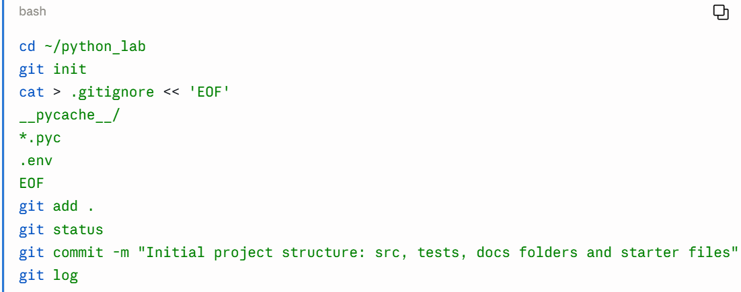.gitignore Explanation:
The .gitignore file tells Git which files and directories to ignore and not track in version control. This prevents unnecessary, sensitive, or auto-generated files from being committed to the repository, keeping the repository clean and focused on actual source code.
Why These Patterns Matter:
The three patterns added to .gitignore serve important purposes: __pycache__/ ignores Python's cache directory that stores compiled bytecode, which is auto-generated when Python runs and is platform-specific, meaning it would differ between developers' machines and serve no purpose in version control. *.pyc ignores compiled Python files that are created when Python imports modules, preventing binary files from cluttering the repository since the source .py files are what matter. .env ignores environment files that often contain sensitive information like API keys, database passwords, and secret tokens, preventing accidental exposure of credentials that could compromise security if the repository is shared or made public.
What Commit History Reveals:
The commit history shows the chronological development of a project, including what changes were made, when they were made, who made them, and why (through commit messages). It provides a complete audit trail of the project's evolution, enables rollback to previous versions if bugs are introduced, helps understand the progression of features and design decisions, and facilitates collaboration by showing who contributed what. Each commit represents a snapshot of the codebase at a specific point in time, allowing developers to track progress, identify when issues were introduced, and understand the context behind changes through meaningful commit messages.
Part C - Writing and Committing Python Code
utils.py Code:
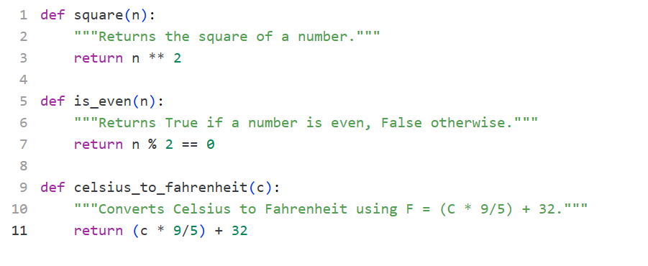
File 2: src/main.py

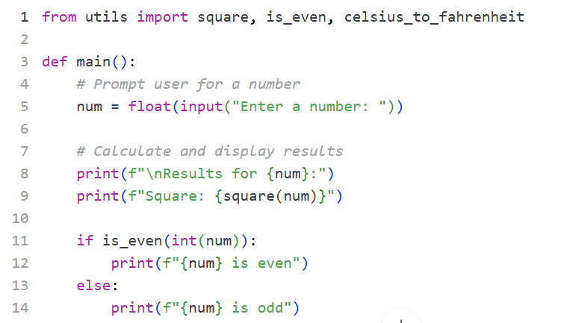
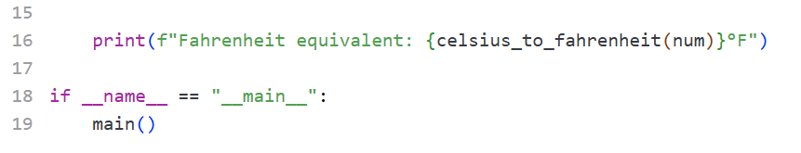
src/config.py
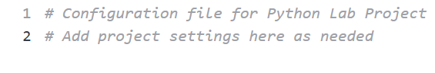
Terminal Commands to Test and Commit:

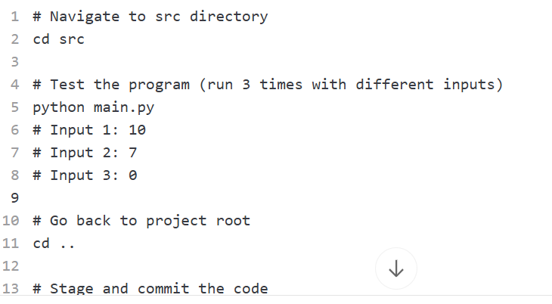
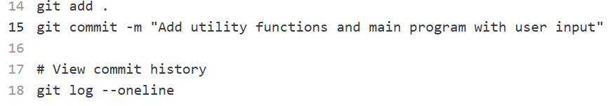

How Python's Import System Works:
Python's import system allows main.py to access functions defined in utils.py through the statement from utils import square, is_even, celsius_to_fahrenheit. When Python executes this import statement, it searches for utils.py in the same directory (or in the Python path), loads the module into memory, and makes the specified functions available in main.py's namespace. This means the functions can be called directly by their names without needing to prefix them with the module name. The import system promotes modularity and code reusability by allowing developers to organize related functions into separate files and import only what they need. It also prevents code duplication, as utility functions can be defined once and used across multiple files in the project.
Test Output Confirmation:

Part D - Publishing to GitHub and Branch Workflow
Screenshot 3: Live GitHub Repository
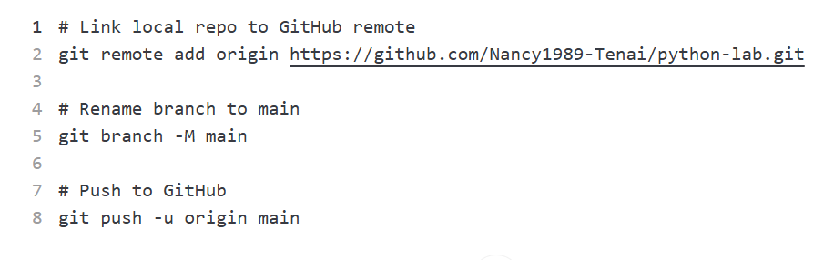Screenshot 4: Open Pull Request
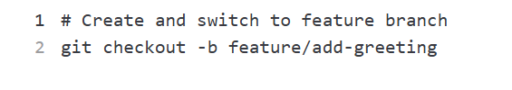

Update src/utils.py

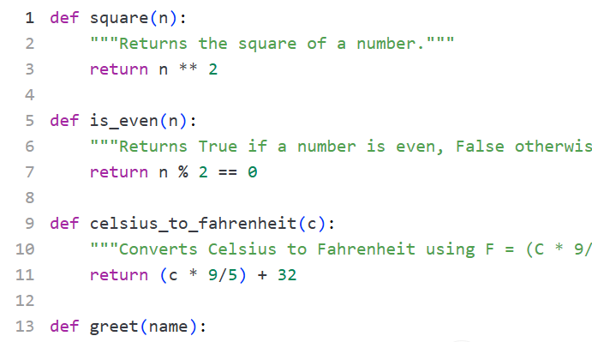
Update src/main.py
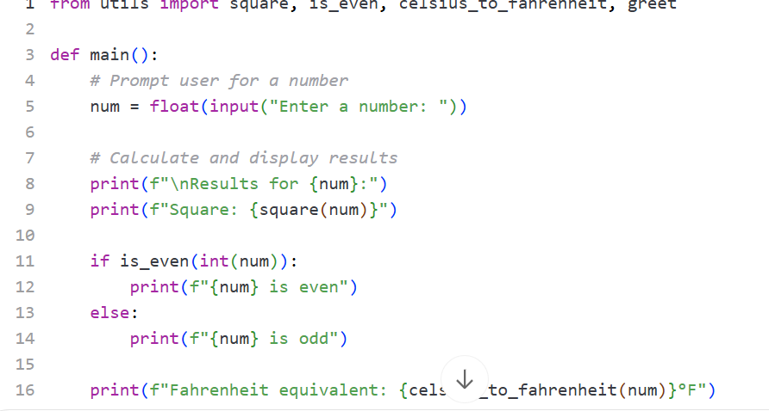
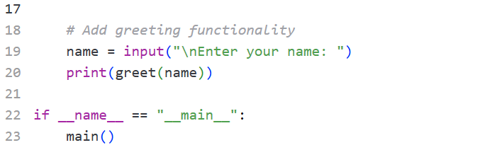
Commit and Push Feature Branch (Terminal Commands)
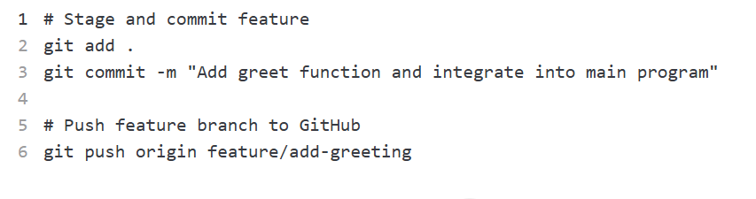

Why Developers Use Branches and Pull Requests:
Developers use branches and pull requests instead of committing directly to main to maintain code stability, enable collaboration, and ensure code quality. The main branch represents the stable, production-ready version of the codebase, and direct commits risk introducing bugs or breaking existing functionality. Feature branches like feature/add-greeting allow developers to work on new features in isolation without affecting working code. Pull requests provide a formal mechanism to propose changes, enabling team members to review code, discuss improvements, and approve changes before merging into main. This workflow supports parallel development, where multiple developers can work on different features simultaneously without conflicts, prevents accidental deployment of incomplete features, and creates a safety net through code review. It also provides documentation of why changes were made and who approved them, creating accountability and traceability in the development process.
What Happens During Code Review:
During code review on a pull request, team members systematically examine proposed changes to ensure quality, correctness, and adherence to standards. Reviewers check for bugs, logical errors, security vulnerabilities, and performance issues while verifying code follows project style guidelines and best practices. They leave comments suggesting improvements, requesting clarification, or asking for additional tests. The review often involves multiple feedback rounds where the author addresses comments by pushing additional commits to the same branch, which automatically update the pull request. Reviewers verify changes accomplish their intended goal, don't break existing functionality (often confirmed by automated tests and continuous integration checks), and are properly documented. Once all concerns are addressed and reviewers approve the changes, the pull request can be merged into main, incorporating the new code into the production branch. This collaborative review process catches issues early before they reach production, shares knowledge across the team, maintains code consistency, and ultimately produces higher-quality software through collective scrutiny and discussion.

